# Agile Concepts

The primary concepts of agile programming is to predict what you can do within a reasonable size and start doing it. By keeping things at a reasonable size it makes it so you don’t have to rush and do sloppy work to meet the end goal. You need to keep in communication with your team at least once a day which is performed during a daily scrum meeting, which is used to say where you are in your assignment and if you are in a good position to meet the goal at the end of the sprint.

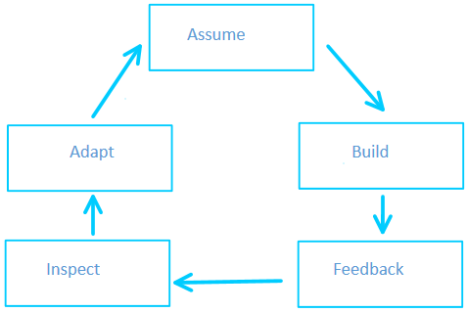 Agile programming uses a constant learning loop that starts off making an assumption, build something pointing towards the goal, receive feedback on what was built, and then use the feedback to inspect what we did relative to what we assumed would occur. This occurs daily and at the end of the sprint which is a way to constantly adapt to problems that arise leading to less down time or less time required to patch the issues that arise.

# Roles in Agile Programming

There are three main roles in agile programming: Product Owner, Scrum Master, and the Development Team. Each role has an important part in the team and each person is responsible for the work that is delivered.

The product owner is a person that keeps in contact with the customer, product sponsors, the scrum master, and the development team. This person is the layer between the customer, product sponsors, and the team. He makes the high level calls and clarifications of the questions asked by the development team. He has the ability at the end of each sprint to continue to the next sprint or halt the production due to time/money/competitor constraints.

The scrum master is the person that coaches the development team. They head the daily scrum meeting and other day to day activities. This person keeps the outside distractions outside as best as possible. They don’t necessarily give out answers, but asks a probing question that will possibly pull the correct answer out. The scrum master helps the team define and adhere to their process for making sure work gets done. This person will perform training to further the teams’ intellect on the scrum process and its inner workings.

The development team perform sprint execution. They decide how to plan, manage, carry out, and communicate their work. Every day they have a meeting on their progress. They groom the product backlog to prepare for the next sprint. At the end of each sprint they inspect and adapt the product and process towards the way that they decide is the end goal, or their definition of done.

# Agile Sprints

Sprints are typically ran in two to four week time spans. This is so they can quickly deliver a shippable product if they need to. This is also a way to frequently get back in line with the ultimate goal, the end product. It is meant at the beginning to define what needs to be done during this sprint. The work is done with meetings daily to keep an accurate idea where everyone is and adapt if problems have arisen to meet their definition of done at the end of the sprint.

At the end of each sprint there is an inspection period that is reflective to the previous sprint and seeing what went wrong and what worked great. Adaptations are made to fix the things that went wrong and to continue to the things that worked great. The shorter sprints allow for the faster feedback like this to make sure that only good things come out of every sprint.

The shorter sprint also allows for the team to get excited for the project again. Excitement can dwindle as sprints get longer and longer and this allows the team to see the progress that has been done already and get excited for the next sprint to see more progress completed.

A goal is set called the definition of done. This is what the team required by the end of the sprint that will deem that the work is indeed complete when the sprint ends. If the goal isn’t completed the item that isn’t up to standard is inserted back into the product backlog to work on a later sprint or the next one if it is in high demand.

The sprints are consistently set so there are no confusion when the sprint starts or ends. If they are two weeks sprints they will not change to three weeks and back or to a different time span. This makes for better planning as well, because the team will know how much they can get done in each sprint and the team won’t be guessing what can be done with each different timed sprint.